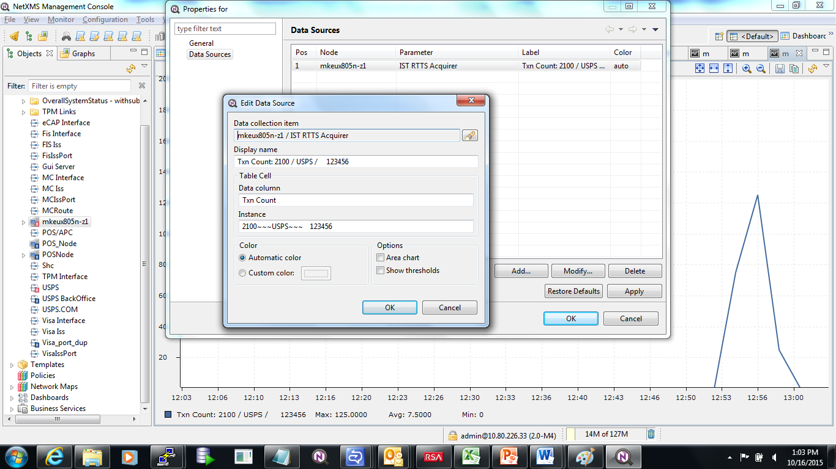
Now I am selecting Show thresholds
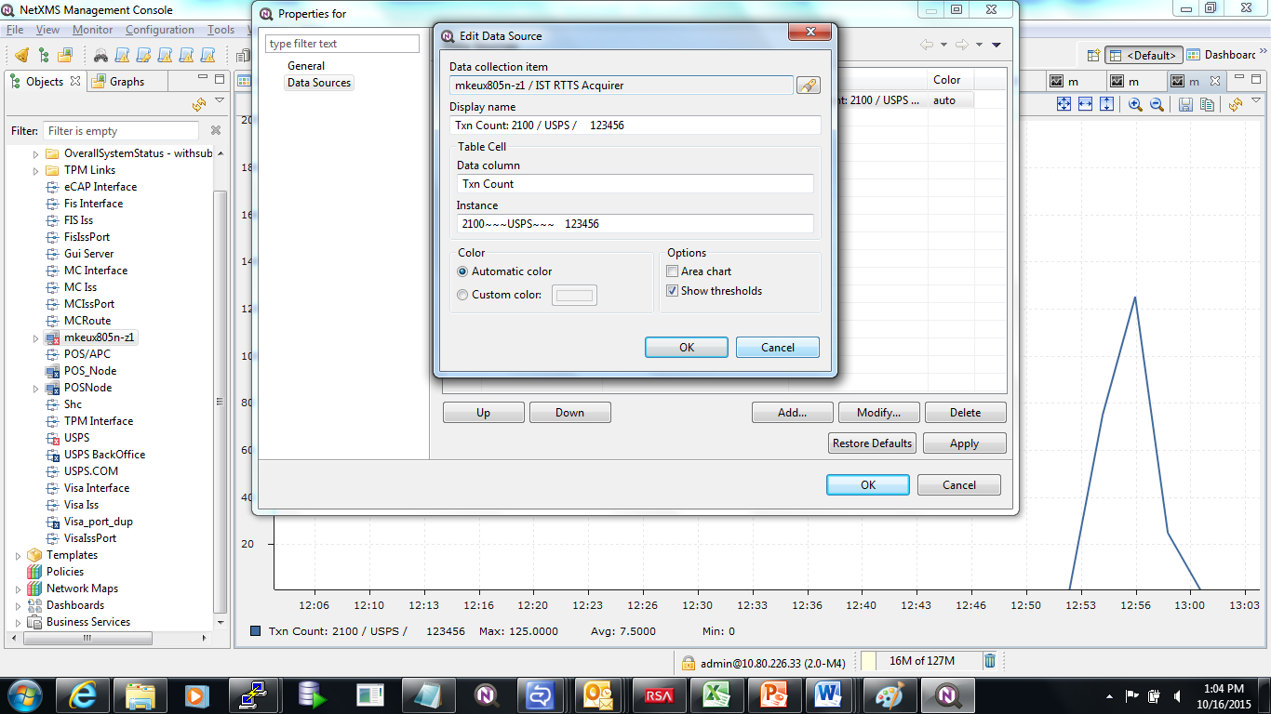
I have click at OK and apply button,

Now I am double checking whether Show threshold got set or not, I am clicking at Modify button
I can see Show thresholds has been set
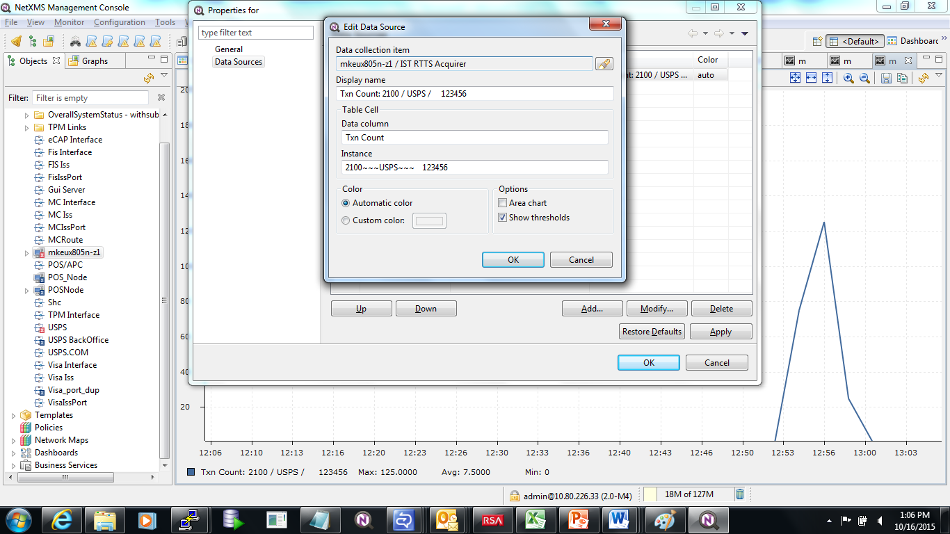

I have click at Ok an apply button again

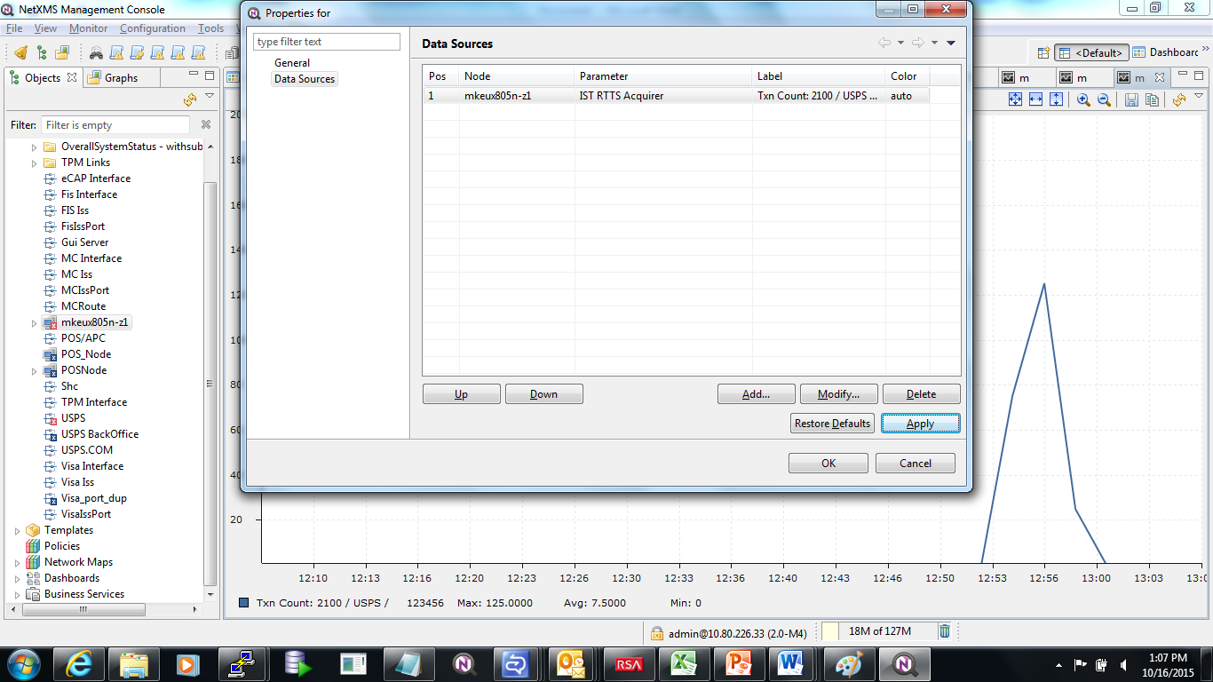
Now on property of data source screen I am clicking at OK button to close it, after closing the properties screen, Now again I opened the property of data source, this time can see that “Show Threshold” option that I have set got unselected

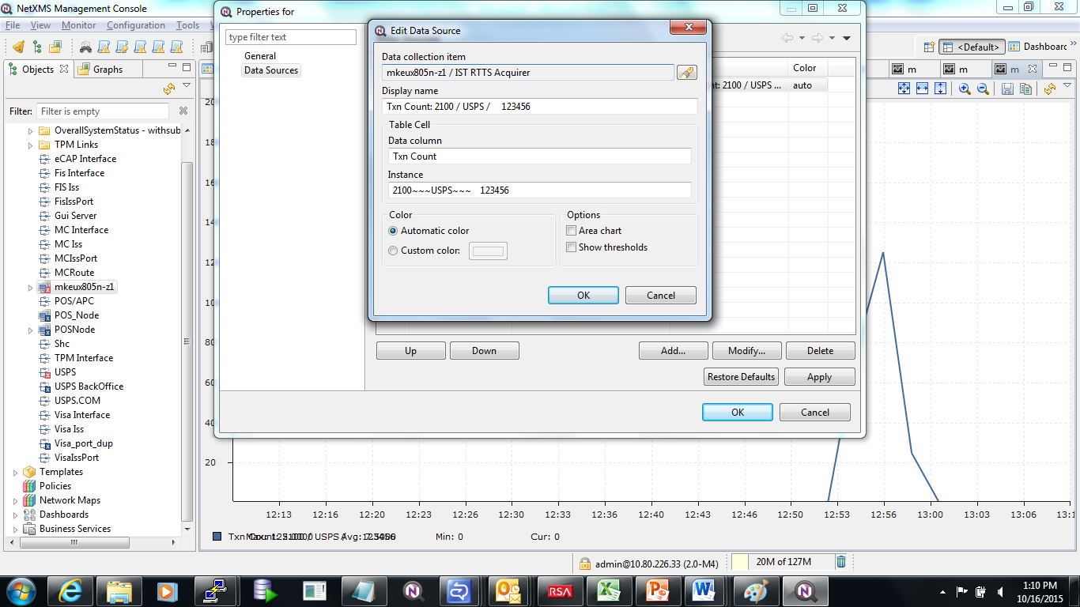

I have a threshold set for this column Txn column, but I could not show it in graph, my expectation is that I need to see striate line appearing from y-axis scale value “10” , is my expectation correct ? or is this bug ? or what is functionality of setting “Show Threshold” option ?


