As suggested by you I have created new node object (POSNode) and I have set status DCI as its status calculator
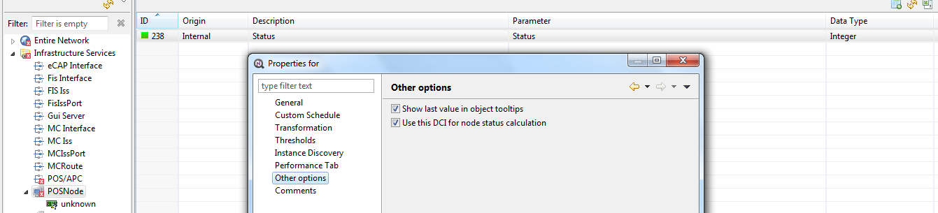
Now based on my transformation script in status DCI, it is returning values (0,1,2,3,4)
However based on status value, the symbol in top-right corner of object image does not change
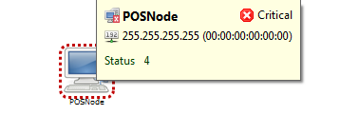
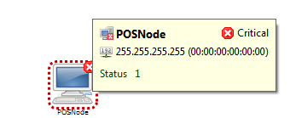

Here is screenshot of Note Object properties


