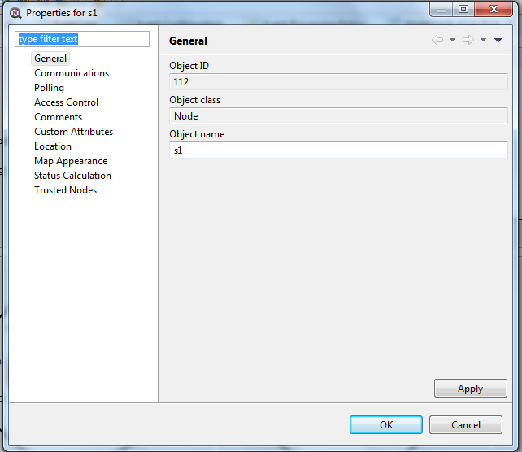

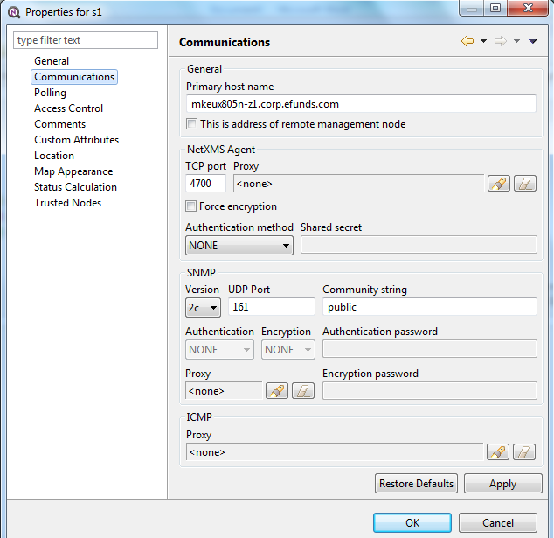

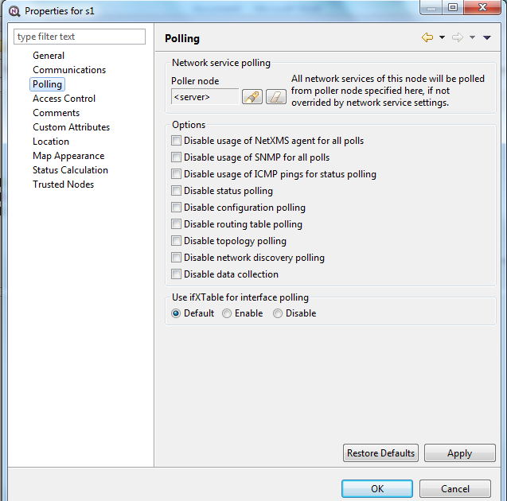

Configuration poll output :
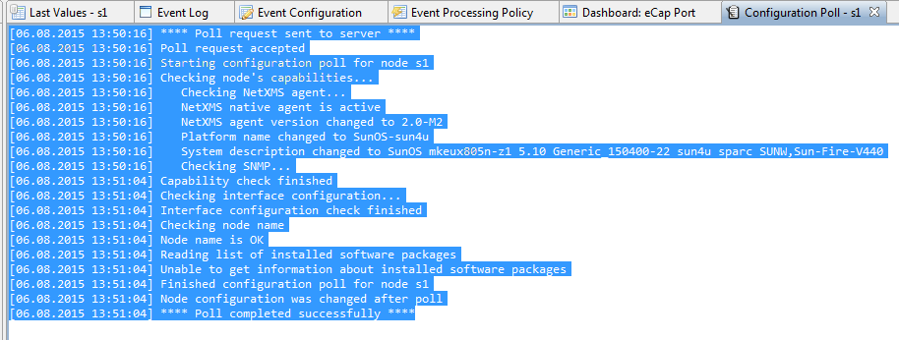

Netstat of port 4700
uspsqa1@mkeux805n-z1-76-SWITCH>> netstat -na | grep 4700
*.4700 *.* 0 0 49152 0 LISTEN
10.80.226.33.40397 10.80.226.33.4700 49152 0 49152 0 ESTABLISHED
10.80.226.33.4700 10.80.226.33.40397 49152 0 49168 0 ESTABLISHED

